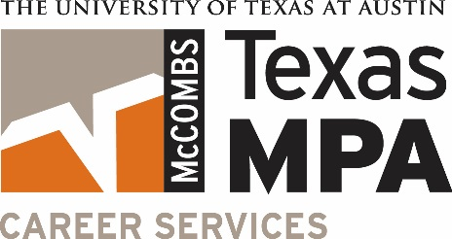
MPA Career Services Student Staff Position Description
Responsibilities
* Responsibilities with asterisk are reserved for student staff with MPA recruiting experience.
- Collaborate with MPA Career Services and other MPA Program staff to:
  - Develop new career materials
  - Plan and manage events
  - Complete special projects
  - Lead small-scale workshops*
  - Attendance at some evening events is required

- Participate in the career portion of ACC 151 by doing the following:
  - Review MPA resumes on Canvas
  - Develop and present material relevant to recruiting and professionalism
  - Participate on student panels to share recruiting experience*
- Hold regular walk-in hours with MPA students to:*
  - Critique resumes and cover letters
  - Conduct and/or provide feedback on mock interviews
  - Provide guidance on navigating the On-Campus Recruiting (OCR) system effectively
  - Recommend appropriate career research materials and tools

- Assist with creating flyers, posters, videos, PowerPoint slides and other marketing tools to inform and encourage student participation in MPA Career Services activities
- Use technology to help track event logistics, build and maintain contact lists, collect and analyze data, and document processes following office standards for maintaining data integrity
- Research and implement effective methods to market and deliver services to students
- Provide a student perspective to continuously enhance the student recruiting experience
- Engage in student staff training sessions
- Other duties as assigned

Required Qualifications
- Exhibits exceptional professionalism, including attire and conduct
- Pursuing an MPA degree and in good standing with the program
- Able to work at least 10 hours per week
- Available to work throughout the summer and for a minimum commitment of two semesters
- Demonstrates desire to help other students
- Possesses good time management skills and a strong work ethic
- Demonstrates strong verbal and written communication skills
- Proficient in Microsoft Word, PowerPoint, and Excel
- Able to work effectively on a team with minimal supervision
- Demonstrates initiative, flexibility, creativity and a desire to learn
- Receptive to feedback

Preferred Qualifications
Applicants who meet the criteria listed above but not those below will still be considered.
- Experience with MPA recruiting
- Experience with mentoring and/or advising
- Proficient in Adobe InDesign and Photoshop and able to learn computer-related tasks quickly

Benefits
- Learn important job search and career development skills while helping others.
- Develop and enhance transferable professional skills in working with teams, process improvement, event planning, public speaking, marketing, advising, leadership, and technical applications.
- Become an expert in the resources offered through the MPA program.
- Gain in-depth knowledge of the recruiting process.
- Interact occasionally with company professionals and recruiters.

Pay
Pay is dependent upon qualifications and experience. Opportunities to advance to senior student staff exist.
Questions?
Contact Michelle Polkinghorn at michelle.polkinghorn@mccombs.utexas.edu.

